**Computer Science – Fundamentals**

**Semester 1**

**BSC109224 Group A**

**Assignment 1**

**Student: Lucas Madeira Maranho**

**Student ID: 76990**

**Lecturer: Eugene O'Regan**

**Assignment 1 – 30%**

SUMMARY

Question 1 Components change 3

Question 2 BIOS and UEFI 4

Question 3 Build computers 7

First scenario: 7

Second scenario: 8

Third scenario: 8

Forth scenario: 8

REFERENCES: 9

*Use diagrams and appropriate referencing in your answers. Upload all documents to Moodle.*

# Q1.*“While the Von Neumann architecture has remained someway intact, there has been dramatic changes in the way each of the components interact with each other to form a cohesive unit.”*

*Figure*

*1*

*-*

*The Von Neumann Architecture*

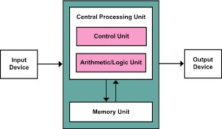

1. Discuss the above statement, taking one of the component’s histories into account. Detail the main changes in this component and how it now interacts with other elements of the model. **(6 Marks)**

**Answer:**

One of the component’s histories that has changed is Monitor.

In past, the quality of monitor was limited in 240p and the answer compared to a real time had a big delay, after few time the quality has been improved and the answer is faster than before, so the way monitor interacts with other components has improved too, for example:

Callbacks system: frameworks are modern with more sophisticated mechanisms which monitoring is an important key.

Visualization tools: dashboards are integrated with, like TensorBoard, weights, that allow data scientist explore model performance.

Another development about monitoring is the size, and to give you a better experience with games for example, some monitors are curved.

1. What would you see as being the main new trends in this component in the near future? **(4 Marks)**

**Answer:**

In the near future, monitor has great opportunities to grow, because now you already have touchscreen monitor, they are becoming thinner and light, 3D interaction better than few years ago and with AI tool growing monitors will be working by itself.

For example:

AI-monitoring: AI automatically identifies when the model performance drops because of some issues.

Real-time and streaming: instant feedback from data quality, feature distribution, etc.

All the pieces of a computer will be in the monitor.

Perhaps, foldable or retractable monitors. **(10 Marks)**

# Q2. – BIOS and UEFI

1. What are the main functions of the BIOS? **(4 Marks)**

**Answer:**

Bios performs a POST that stand for power-on self-test when the computer is powered on.

Check hardware components, such CPU, RAM, hard drives if they are working correctly.

If there are some problems BIOS detect and emit some beeps or error messages.

Examples about the beeps:

DRAM refresh failure, 1 short beep.

Parity circuit failure, 2 short beeps.

Base 64 K RAM failure, 3 short beeps.

System time failure, 4 short beeps.

Processor failure, 5 short beeps.

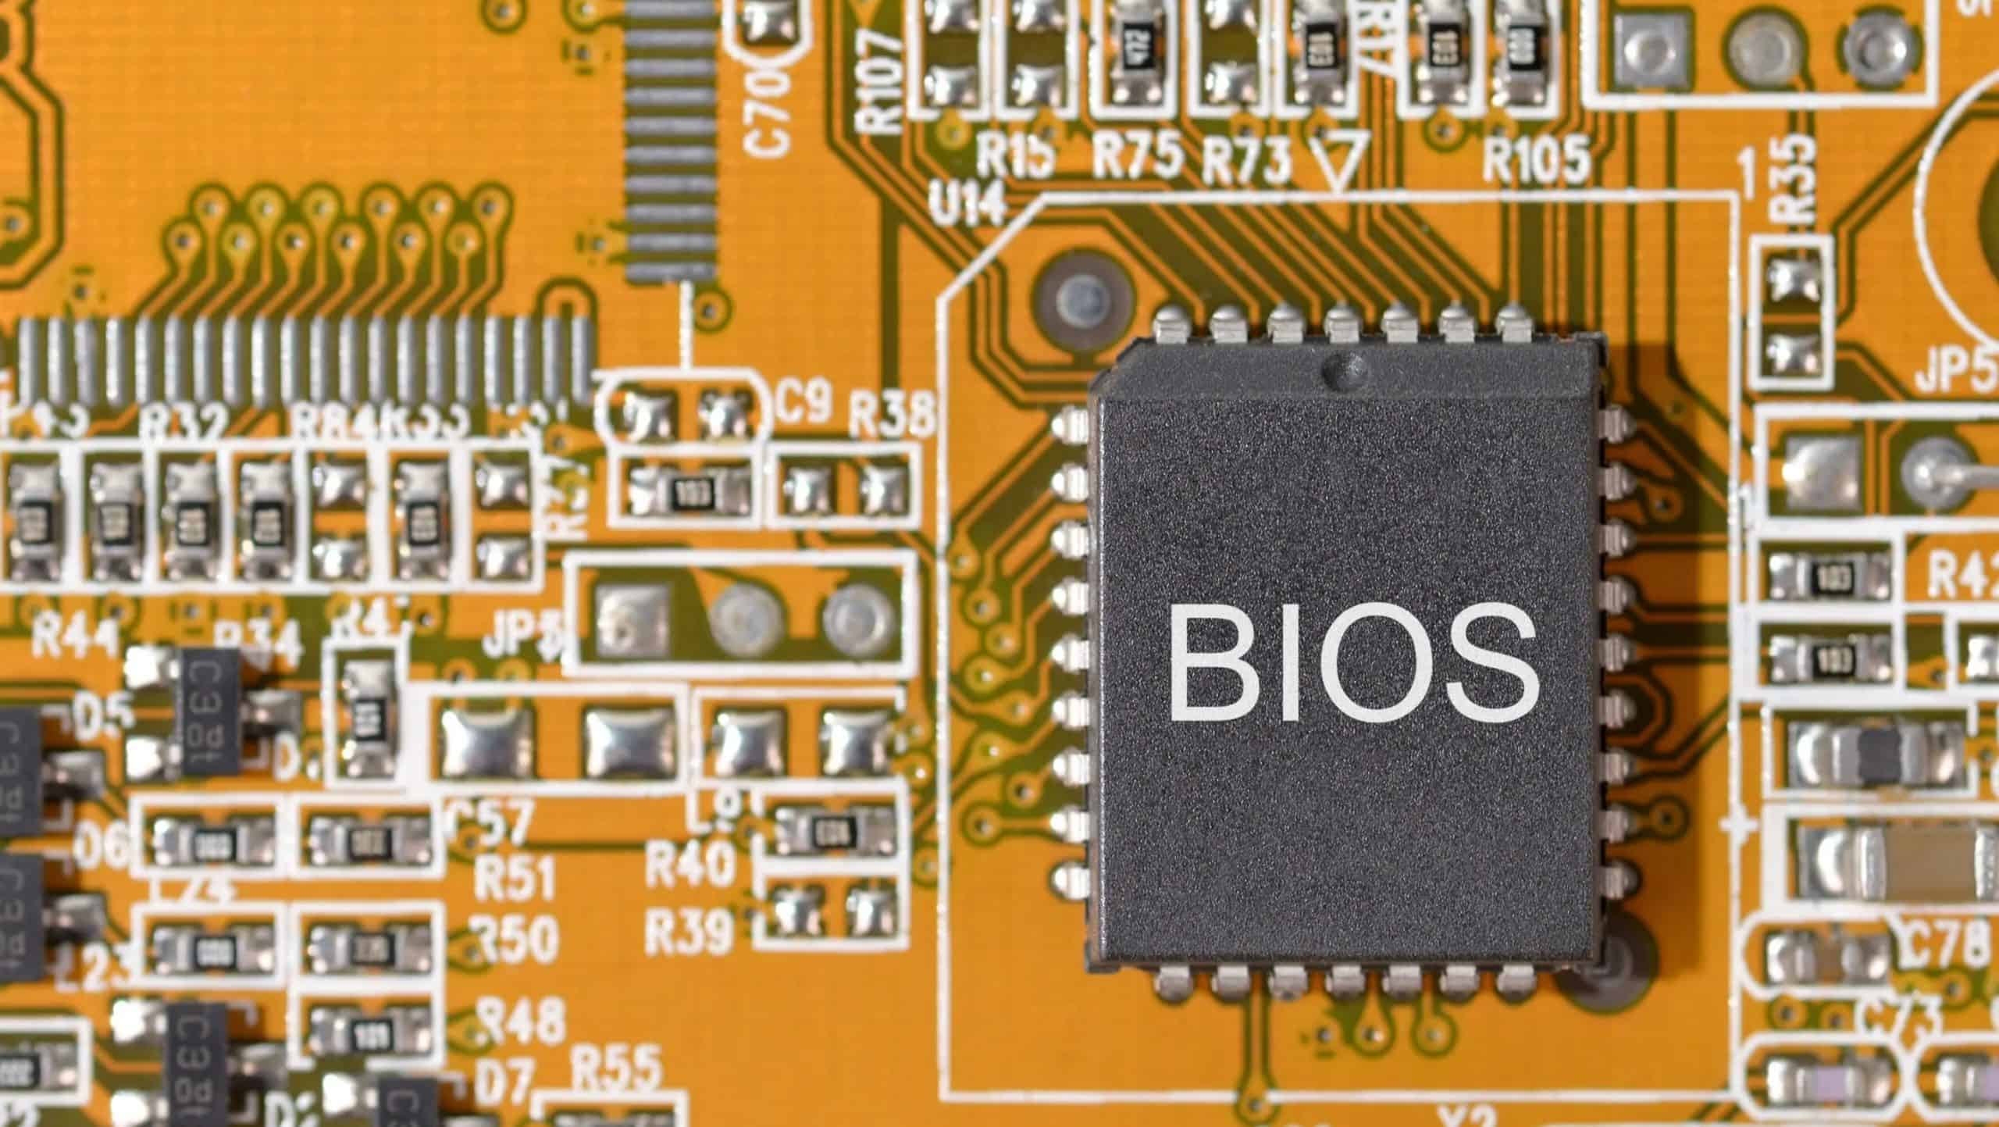

Figure 2- <https://www.gtweb.net/what-is-a-bios/>

1. What security measures can be implemented at various levels in the BIOS? **(3 Marks)**

**Answer:**

Some of security measures that are essential for you and your device:

You can configure the BIOS settings, using the secure boot help, so you can control which apps will operate when the system is loading, preventing the execution of dubious codes startup.

Other methods that you can use to secure your BIOS are:

-password. – User must enter a password before the OS allowing most other hardware to start.

-Full disk encryption (FDE) – Turning the information in secret format which people or systems authorized, understand and access the information.

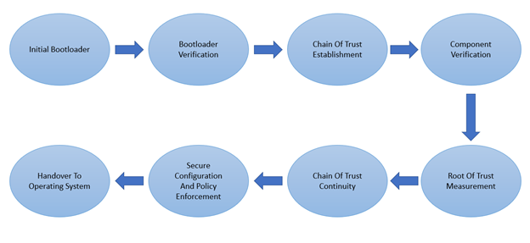

Figure 3 - https://www.einfochips.com/blog/how-secure-boot-help-to-secure-iot-device/

1. Distinguish UEFI from BIOS **(3 Marks)**

**(10 Marks)**

**Answer:**

UEFI – Unified Extensible Firmware Interface.

BIOS – Basic Input Output System.

Both it does the same job, but the purpose of UEFI is store all data about device initialization and startup in a .efi file, which kept on a disk partition called the EFI system, different from BIOS which stores it on a firmware.

EFI hold the bootloader responsible for booting the operating system.

UEFI provides better security, avoiding apps from booting.

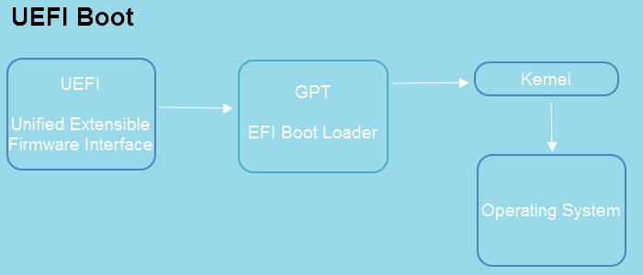

Figure 4 - https://www.easeus.com/partition-master/enable-disable-uefi-mode.html

Other examples that is better in using UEFI than BIOS:

UEFI support much greater drives than BIOS.

Faster boot time.

UEFI runs in 32bit or 64 mode, providing a graphical user interface while BIOS runs in16bit mode.

Interface’s difference:

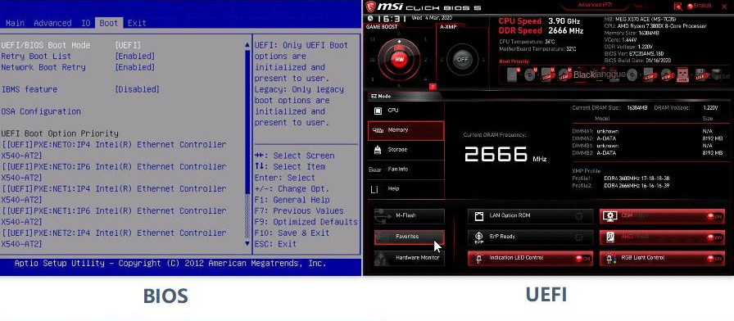

Figure 5 - https://www.reneelab.com/clone-uefi-disk.html

# Q3. – Constructing and Configuring Optimal Computer Systems for Diverse User Needs and Budget Constraints

You are tasked with designing computer systems for different types of users, each with unique requirements and budget constraints. Using the following scenarios, build an appropriate computer system for each user. Ensure you list all key components (CPU, motherboard, RAM, storage, GPU, PSU, etc.) within the specified budget. Additionally, reference any sources you use to confirm component prices and compatibility.

Ensure that your configurations are optimized for each user's needs. You can refer to these links as a tool for virtual PC building

* [https://pcbuilder.net/list/,](https://pcbuilder.net/list/)
* <https://www.pcspecialist.ie/custom-pc/>

**Scenarios**:

1. A home office worker with a budget of **€500 to €1000** who requires a PC for multitasking, video conferencing, and light photo editing.
2. A beginner streamer with a budget of **€1000 to €1500** who wants to stream games on platforms like Twitch and YouTube and needs smooth 1080p streaming performance.
3. An architect with a budget of **€1500 to €2000** who needs a PC for CAD, 3D rendering, and software like AutoCAD, Revit, and Rhino.
4. A professional game developer with a budget of **€2000+** who requires high-end performance for 3D game design, VR development, and testing game environments.

**Mark Distribution**:

* **6 marks** for detailed system builds for each scenario (1.5 marks each).
* **2 marks** for accurate and appropriate references (component prices, compatibility).
* **2 marks** for miscellaneous considerations, such as balance between performance and cost, and adherence to user needs.

(10 marks)

## First scenario:

CPU – AMD RYZEN 5 5500 4.2GHZ 6 CORE 12THREADS

MOTHERBOARD – MSI B550-A PRO AM4 DDR4 ATX

RAM – 16GB DDR4 3200MHZ

STORAGE – 1TB NVMe SSD Boot drive

GPU – MSI Geforce RTX 4060 8gb GDRR6 ada lovelace

PSU – 550 watts

CASE – Thermaltake S200 tg argb Snow ATX Tempered Glass Mid Tower WITH 120mm ARGB

**Monitor, keyboard and mouse NOT included.**

Price: 824 dollar or 781.51 euros quotation from 17/11/2024

## Second scenario:

CPU – AMD RYZEN 5 7600x 6-Core, 12-thread

MOTHERBOARD – ASUS Prime X670E-PRO

RAM – DDR5 32GB (2X16GB) 7600MT/s

STORAGE – Samsung EVO 970 1TB Gen3 x4 NVMe M.2-2280

GPU – GeForce RTX4060 TI Eagle OC ICE 8GB GDDR6

PSU – 1000watts

CASE – NZXT H510-CA-510B-W1 -Compact ATX Mid-tower PC – Tempered glass

**Monitor, keyboard and mouse NOT included.**

Price: 1.492 dollar or 1.415,33 euros quotation from 17/11/2024

## Third scenario:

CPU – Intel i7-14700K,20 cores 28Threads

CPU COOLER – master hyper 212 evo, 4 CDC Heatpipes, 120mm

MOTHERBOARD – ASUS PRIME H770-PLUS D4 intel

RAM – Patriot Viper Xtreme 5 RGB DDR5 32GB (2X16GB) 8000MHz

STORAGE – Samsung EVO 970 1TB PCIe Gen3 x4 NVMe M.2-2280 Internal Solid-State Drive with V-NAND Technology & 1024MB Cache

GPU – Power Color R9 280X 3GB GDDR5Graphics Card AXR9 280X 3GBD5-DHE

PSU – Thermaltake Toughpower GX3 850W 80Plus Gold

CASE – NZXT H510 - CA-H510B-B1 - Compact ATX Mid-Tower

**Monitor, keyboard and mouse NOT included.**

The third scenario I add a CPU COOLER, because the CPU doesn’t come with stock cooler.

Price: 1.680 dollar or 1.594,33 euros quotation from 17/11/2024

## Forth scenario:

CPU – AMD R9 7950X3D

CPU COOLER – NZXT Kraken 240

MOTHERBOARD – ASRock X670E

RAM – 64gb (2 x 32GB) DDR5-600

STORAGE – 2TB Samsung M.2 SSD

GPU – RTX 4090

PSU – SeaSonic Focus V3 GX 850W

CASE – dark base pro-901

**Monitor, keyboard and mouse NOT included.**

Although intel has a better processor developing games, AMD was chosen.

Price: 3.700dollar or 3.510,36 euros quotation from 17/11/2024

# REFERENCES:

Question 1

exercise 1:

<https://blog.acer.com/en/discussion/1907/future-of-display-technology-beyond-oled-and-lcd#:~:text=As%20OLED%20and%20LCD%20technologies,the%20risk%20of%20burn%2Din>.

Question 2:

exercise 1:

<https://ipwithease.com/what-is-bios-in-a-computer-functions-and-types/>

exercise 2:

<https://firmguard.com/securing-bios-firmware-common-pitfalls-and-best-practices/#:~:text=Configuring%20BIOS%20settings%20correctly%20is,potentially%20malicious%20code%20during%20startup>.

<https://www.knowledgehut.com/blog/security/what-is-bios-security>

<https://www.trentonsystems.com/en-us/resource-hub/blog/how-to-secure-your-bios>

exercise 3:

<https://www.freecodecamp.org/news/uefi-vs-bios/#:~:text=UEFI%20stands%20for%20Unified%20Extensible,storing%20it%20on%20the%20firmware>.

<https://phoenixnap.com/kb/uefi-vs-bios>

Question 3:

First scenario:

<https://www.velocitymicro.com/blog/multitasking-pc/#:~:text=Processor%20(CPU)%3A&text=Opt%20for%20a%20multi%2Dcore,multitasking%20needs%20of%20most%20users>.

<https://pangoly.com/en/compatibility/amd-ryzen-5-5500/motherboard>

<https://www.laptopsdirect.ie/stormforce-onyx-ryzen-5-5500-16gb-ram-1tb-ssd-rtx-4060-windows-11-gaming-pc-7873-1408/version.asp>

<https://pcbuilder.net/list/>

<https://www.userbenchmark.com/System/MSI-MPG-B550-GAMING-PLUS-MS-7C56/195347>

Second scenario:

<https://www.laptopsdirect.ie/content/pcs/gaming>

<https://www.caseking.de/en/gaming-pc-black-out-amd-ryzen-5-7600x-nvidia-geforce-rtx-4060-ti-pre-built-pc/SIPC-625.html>

<https://pcbuilder.net/list/>

<https://www.userbenchmark.com/System/MSI-MPG-B550-GAMING-PLUS-MS-7C56/195347>

Third scenario:

<https://www.laptopsdirect.ie/dell-precision-3660-tower-mt-core-i7-32gb-1tb-ssd-windows-11-pro-09vnp/version.asp>

<https://www.laptopsdirect.ie/dell-precision-3660-tower-mt-core-i7-32gb-1tb-ssd-windows-11-pro-09vnp/version.asp>

<https://www.userbenchmark.com/System/MSI-MPG-B550-GAMING-PLUS-MS-7C56/195347>

Forth scenario:

<https://www.userbenchmark.com/System/MSI-MPG-B550-GAMING-PLUS-MS-7C56/195347>

<https://www.logicalincrements.com/articles/build-pc-game-development>

quotation from all scenarios:

<https://www.xe.com/pt/currencyconverter/convert/?Amount=824&From=USD&To=EUR>